More than a Mile Deep Global
Grassroots Learning Response Report on
Life and Calling of a Pastor (LCP)

Report Submitted to:
MMD-G leadership

Compiled by
Alpheus Banda

JUNE, 2018

It is illegal and a violation of Christian ethics to reproduce all or any part of this report in any form
without prior written permission from
More than a Mile Deep.

Copyright © 2017 by More than a Mile Deep
All rights reserved

Acknowledgement

I would like to thank God for his goodness and mercies toward his people.

I would like also to thank the following people who have contributed to this project in various ways: Richard Morris, MMD-G Consultant, for his leadership and coaching role in this project, Victor Lonu, MMD-G facilitator and course editor, for conducting the project in Kenya and Congo; Dr. John Jusu, MMD-G Curriculum Architect; Regina Manley, Oral learning Consultant, for compiling statistics for this report; Nicholas Ivin, Former MAR Learning Technologies Consultant.

Table of Contents
ABBREVIATIONS 6
1.0. INTRODUCTION 7
2.0. PROJET RATIONALE 8
2.1.0. What triggered this project 8
2.2.1. The demand for transformational grass root training curriculum 8
2.2.2. The need to reach out to more pastors with ARA led curriculum 9
2.2.3. Reflection on lessons learnt by MMD-G Educational Team for grass root responses 9
2.2.3.1. Alpheus Katiyi Banda (Malawi), Country Coordinator, Facilitator, Course Writer & Editer 10
2.2.3.2. Victor Budha Lonu VICTOR LONU (DRC, living in Kenya): Junior Course Editor, Junior Coach (Open Door’s Francophone Teams, Burundi Facilitators/Writers) 10
2.2.3.3. Dr. JOHN JUSU, (Sierre Leone, living in Kenya), Curriculum Director, Chief Curriculum Architect, Senior Consulting Coach 10
2.2.3.4. Richard Morris (Britain, living in USA), MMD-G Coach and Consultant 11
3.0. THE CURRICULUM DEVELOPMENT PROJECT 11
3.1. Composition of the Team 11
3.2. The Process 11
3.2.1. Context Analysis 12
3.2. 2. Development of the Curriculum 13
3.2.3. Pre-testing 13
3.2.4. Editing and Revision 13
3.2.5. Facilitators Training 13
3.2.6. Impact Evaluation 14
3.2.6.1. Purpose of the Evaluation 14
3.2.6.2. Scope of the Evaluation 14
3.2.6.3. Methodology 14
3.2.6.4. Sample Size 15
3.2.6.5. Limitations 17
4.0. FINDINGS AND IMPACT OF THE PROJECT 17
4.1. Quantitative Findings on Impact of the Project 17
4.1.1. Pastor Meeting the Needs of his or her Family (children and wife) 17
4.1.2. Pastor equipping other people in their congregations for ministry 19
4.1.3.0. Build rhythm with self, family and ministry 21
4.2.0. Qualitative Findings and Impact of the Project. 23
4.2.1. Direct Impact (Impact on the Individual) 24
4.2.2. Ministry Impact (Impact on the Family) 26
4.2.3. Community Impact (Impact on the Congregation) 27
5.0. LESSON LEARNT 28
5.1. The need for Grass root training programs in Africa Exists 28
5.2. There is need for ARA Curriculum (Transformational Learning Responses) for Grass root pastors and we can design them. 28
5.3. ARA grass root learning responses can be multiplied by building an effective incubation program in a country among grass root pastors. 28
7.0. OTHER GRASS ROOT PROGRAM GOALS BEYOND 2018 29
APPENDANCES 30
Appendix 1: MMD-G Non-accredited Projects Plans 30
Appendix 2: Chain of Impact from Projects–Definition & Measurement 31
Bibliography 35

ABBREVIATIONS

ARA : Acting, Reflecting & Acting
AS : Africa Services
EAM : Evangelical Association of Malawi
FGW : Farming God’s Way
GATE : Global Associates for Transformational Education
LCP : Life and Calling of a Pastor
Level C : A third level in MMD-G training system usually related to
Church and Church organizations
MMD-G : More than a Mile Deep Global
PTI : Partners Trust International

1.0. INTRODUCTION
More than a Mile Deep Global referred to as MMD-G is a not-for-profit educational service provider organization. Its goal is to improve capacity of Churches and Church related organizations in designing and delivering Biblical training programs aimed at transforming people and their communities holistically. MMD-G builds contextually relevant educational curriculum which facilitates transformation of varying situations in the most encouraging ways using acting, reflecting and acting (ARA) learning methods. This report is MMD-G’s grass root learning response project report on Life and Calling of a Pastor (LCP) submitted to MMD-G leadership. The report highlights the rationale of the grass root learning response, key achievements, lessons learned and proposed way forward among other things.
The grass root learning response on life and calling of a pastor was a three years pilot project implemented by MMD-G in Congo, Kenya and Malawi from 2015 to 2017. The project was designed primarily to respond to two major assumptions held by MMD-G at that time. First, the need for developing ARA grass root related curriculum in the MMD-G’s training system which could be used or adapted by its Level C partners (Churches and Church organizations). Second, the need for responding to the well being of grass root pastors in Africa. Generally, many pastors in Africa are serving in rural, hard to reach areas and among the unreached people.
Sixty (60) grass root pastors and church leaders from Congo, Kenya and Malawi participated in this project. They took a grass root learning response which was titled Life and Calling of a Pastor (LCP) for a period of one year. The learning response was developed by a team of ten people from MMD-G (details of the team is provided later in this report). It used extended seminars mode of delivery and post seminar assignments. The seminars took a total of twelve (12) days while all the post seminar assignments took a total of nine (9) months. Each seminar had three days of contact hours between facilitator and participants with a total of six contact hours. The response had a total of three (3) seminars. At the end of each seminar, participants were asked to conduct post seminar assignments (practical assignments) covering a period ranging from one to three months. Participants were asked to provide a report on their post seminar assignments at the beginning of each following seminar. Thus, each following seminar was beginning with a reflection on what has happened in the life of the pastor as a result of the assignment. For example, a reflection of post seminar one was provided on the first day of seminar two etc. The seminars provided a reflecting opportunity for discovery learning in the pastors’ situations. As bait, each seminar module was not complete until the participant had at least attended 3 days of seminar, reflected on their situation and acted through post seminar assignments.
Some of key achievements of this project are summarized as follows:
- Development and testing of the first MMD-G’s ARA grass root learning response;
- Significant changes experiences of transformation in areas relating to family, ministry and personal well among grass root pastors through ARA.
- Incubating grass root pastors as ARA learning response facilitators to replicating it into their communities and congregations
- Evidences of improved capacity of pastors to respond Biblically into their situations and bringing in about transformation.

2.0. PROJET RATIONALE

2.1.0. What triggered this project
For example, a study conducted in Malawi, Kenya and Congo revealed that (85)% of grass root pastors are facing challenges relating to taking care of their families, congregations and themselves contributed in many cases primarily by lack of financial support.
Pastors and church leaders living in rural places in Africa face many challenges which negatively affect the well being of their families and ministries. Although these pastors hold the greatest responsibility of leading, teaching, preaching and counseling God’s people, in many cases challenges related to well being of their families and ministries affect on overall their potential to bring about Biblical transformation in the communities where they are serving. Consequently, this affects their view of themselves and ministry. For example, a study conducted in Malawi, Kenya and Congo revealed that (85)% of grass root pastors are facing challenges relating to taking care of their families, congregations and themselves contributed in many cases primarily by lack of financial support from their sending Churches and poor living conditions of their church members.
In 2015, MMD-G designed an ARA grass root curriculum to respond the above situation. The curriculum was implemented in three countries of Congo, Kenya and Malawi. It overall goal was to equip grass root pastors with skills to balance their obligations towards family, ministry and calling. Three outcomes were outlined as follows:
- Meeting the needs of his or her family
- Equipping people in his or her congregation for ministry
- Building rhythm of life and calling

2.2.0. Factors that triggered the project

Factors which triggered the development of this project were as follows:

2.2.1. The demand for transformational grass root training curriculum
First, the demand for transformational learning programs among grass root pastors in Africa triggered the project. It triggered the project through Churches and Church organizations’ demand for effective transformational grass root training programs. It is assumed that most of the unreached people in Africa are found in rural areas and majority of pastors serving among them are uneducated. The main challenge is that most of the present training programs are yielding minimal results relating transformation of people and their communities. Furthermore, most of the pastors who get the opportunity of taking these trainings end up serving in urban areas unlike the rural areas where the need is great. This is what prompted some organizations like Africa Services (AS) in South Africa and Partners Trust International (PTI) in Burundi to look for models in Africa which are yielding better results among grass root pastors. In 2015, a team of MMD facilitators were seconded to help PTI. A team of MMD-G consultants, Dr. John Jusu, Richard Morris and Victor Lonu meet PTI to discuss with them. What transpired at that meeting was demand for ARA courses targeting grass root learners unlike the current Bachelor of Theology (BTh) curriculum which MMD-G is offering.
In the same year (2015) MMD-G was invited by AS to build capacity of its training system on delivering transformational curriculums. However, one of the challenges was that MMD-G did not have a grass root curriculum at that time which other organizations can model. PTI and AS’s demand for MMD-G to build their capacity for transformation learning responses triggered the leadership of MMD-G to get on this project.

2.2.2. The need to reach out to more pastors with ARA led curriculum
Consequently, the need in MMD-G leadership to reach out to more grass root pastors with ARA led curriculum was what triggered this project in the second place. MMD-G’s desire is that more Churches, Theological Schools and Para – Church organizations are aware of ARA curriculum and using it in their training programs. And since the majority of pastors in Africa are grass roots and many of them not have the qualification to enroll into the BTh program (as the case with some countries), there was a need to develop an ARA model of MMD-G curriculum that targeted grass root pastors. The aim of this curriculum was to facilitate the same level of transformational results without requiring grass root pastors to meet standard requirements for a BTh curriculum. Since MMD-G curriculums are traditionally designed for a BTh level, the need was therefore to develop an ARA curriculum which also targets grass root pastors.

2.2.3. Reflection on lessons learnt by MMD-G Educational Team for grass root responses
As the MMD-G was responding to the emerging demands for transformational learning among its partners, the leadership established a team of six people to reflect on the need. This team was comprised of individuals with variety of expertise and experience in grass root learning response. The team was lead by Richard Morris, MMD-G Consultant and had the following people: Alpheus Banda (MMD-G facilitator and course editor), Victor Lonu (MMD-G facilitator and course editor), Richard Morris (MMD-G Consultant), Dr. John Jusu (MMD-G Curriculum Architect), Regina Manley (Oral learning Consultant) and Nicholas Ivin (Former MAR Learning Technologies Consultant).
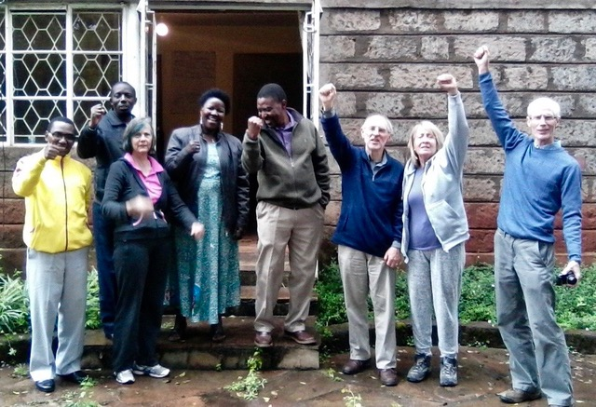
MMD-G grass root team, Nairobi, Kenya, 2016
Here is how the process of reflecting on the development of ARA grass root learning responses was recorded.

2.2.3.1. Alpheus Katiyi Banda (Malawi), Country Coordinator, Facilitator, Course Writer & Editer
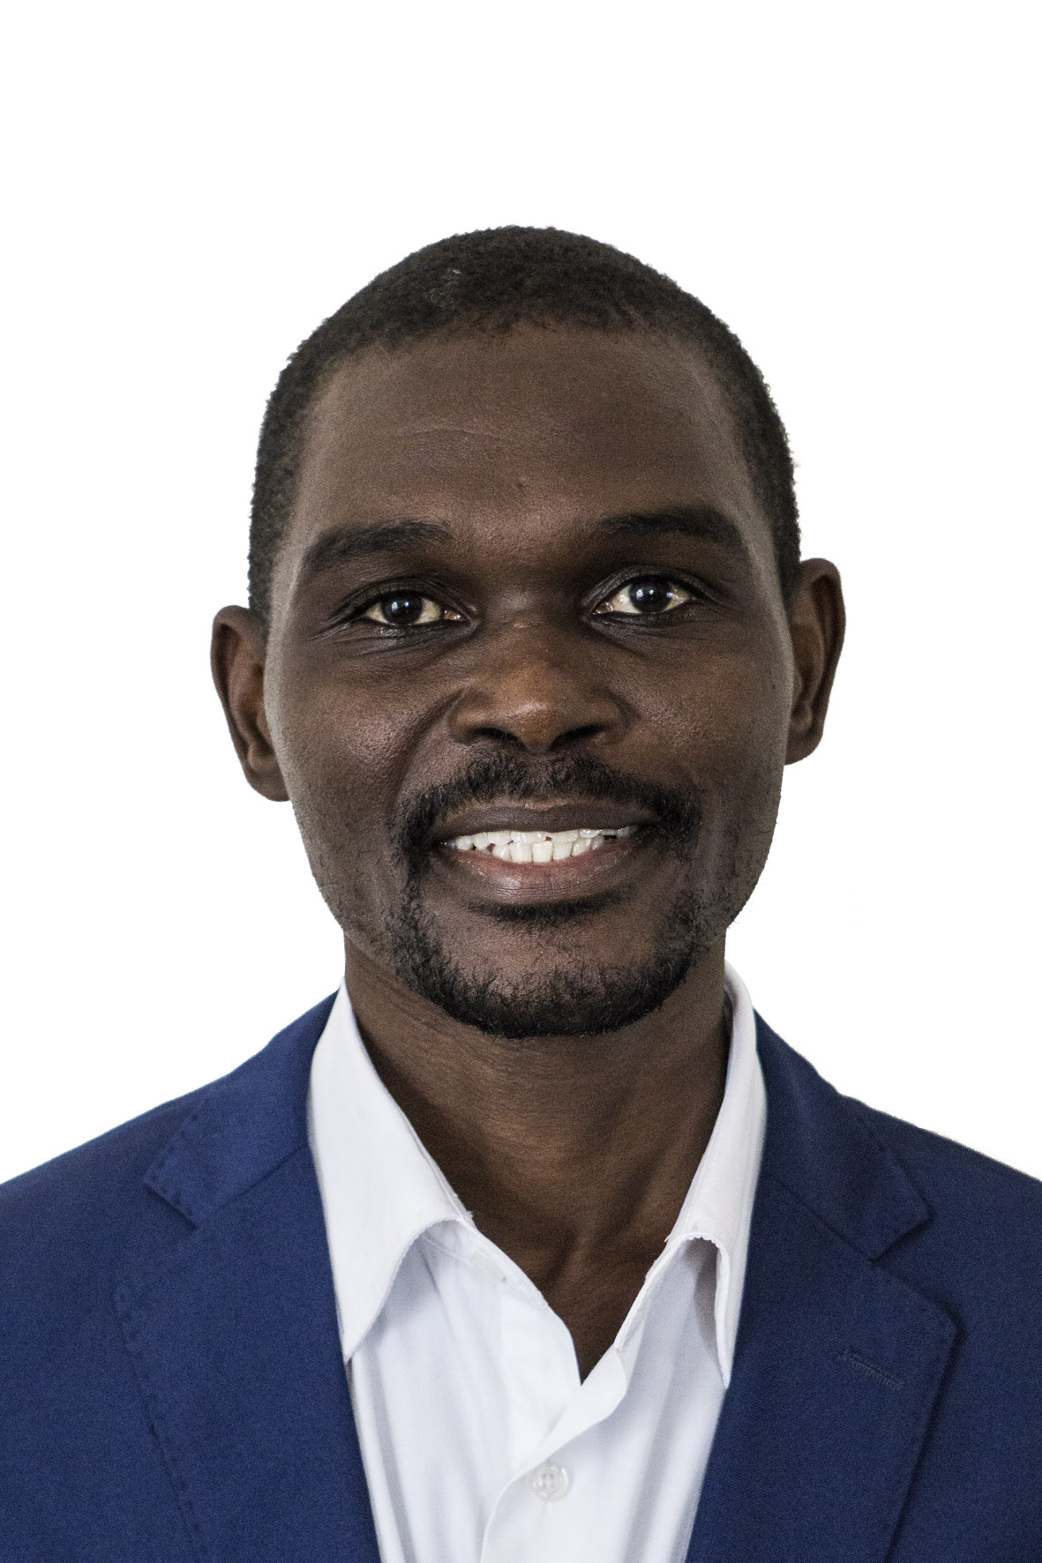
In 2015, Alpheus Banda, based in Malawi was being trained as MMD facilitator and course writer. Alpheus took a number of MMD courses in order to experience the model. At the same time, Alpheus was working with Evangelical Association of Malawi (EAM) were his role was designing and delivering training programs for grass root pastors among EAM’s church members. In 2016, Alpheus designed the first ARA grass root training extended seminar for EAM pastors using an MMD-G BTh courses, Resolving Poverty and Ethnic Divisiveness. Alpheus asked permission from Richard Morris who was his coach about this idea. He designed a 3 by 3 grass root seminar model. This included 3 days of training (seminar) and 3 months of post seminar assignments. 20 pastors from Thavite in Salima district, Malawi participated. The training model was successful in engaging grass root pastors and Church leaders who did not have the qualification to enroll to the MMD BTh program to experience ARA learning responses and transformation of their situations.


2.2.3.2. Victor Budha Lonu VICTOR LONU (DRC, living in Kenya): Junior Course Editor, Junior Coach (Open Door’s Francophone Teams, Burundi Facilitators/Writers)
In the same year (2015), Victor Lonu based in Kenya was also being trained as a MMD facilitator and course writer. Victor was also involved in coaching and training course writers from Partners Trust International (PTI), an organization founded by one of MMD staff in Burundi. While Victor was helping PTI’s course writers, he realized that the organization was struggling formatively in designing its course. Victor realized that although PTI’s focus was grass, the courses which they are writing were more less being developed at a BTh level. In fact, he felt that they were basically adoptions of the BTh curriculum. His observation was that many of the pastors whom the courses were being written for would not have capacity to take them. He also realized the writers were finding it difficult to write the course because of the same challenge. Through reflecting and talking about this, Victor, Dr. John Jusu and Richard Moriss started talking about developing a completely new model of grass root curriculum for PTI. The following year, (2016), Victor attended a workshop organized by Global Associates for Transformational Education (GATE) in Nairobi where Dr. John Jusu, MMD-G Curriculum Architect, was facilitating. The workshop was focusing on developing transformational learning responses among theological institutions. It was attended by heads of theological institutions in Nairobi. John’s presentations inspired Victor to start thinking of a simplified model of theological curriculum suitable for grass root pastors. This happened a the time when Victor had just completed editing one of the courses for PTI.

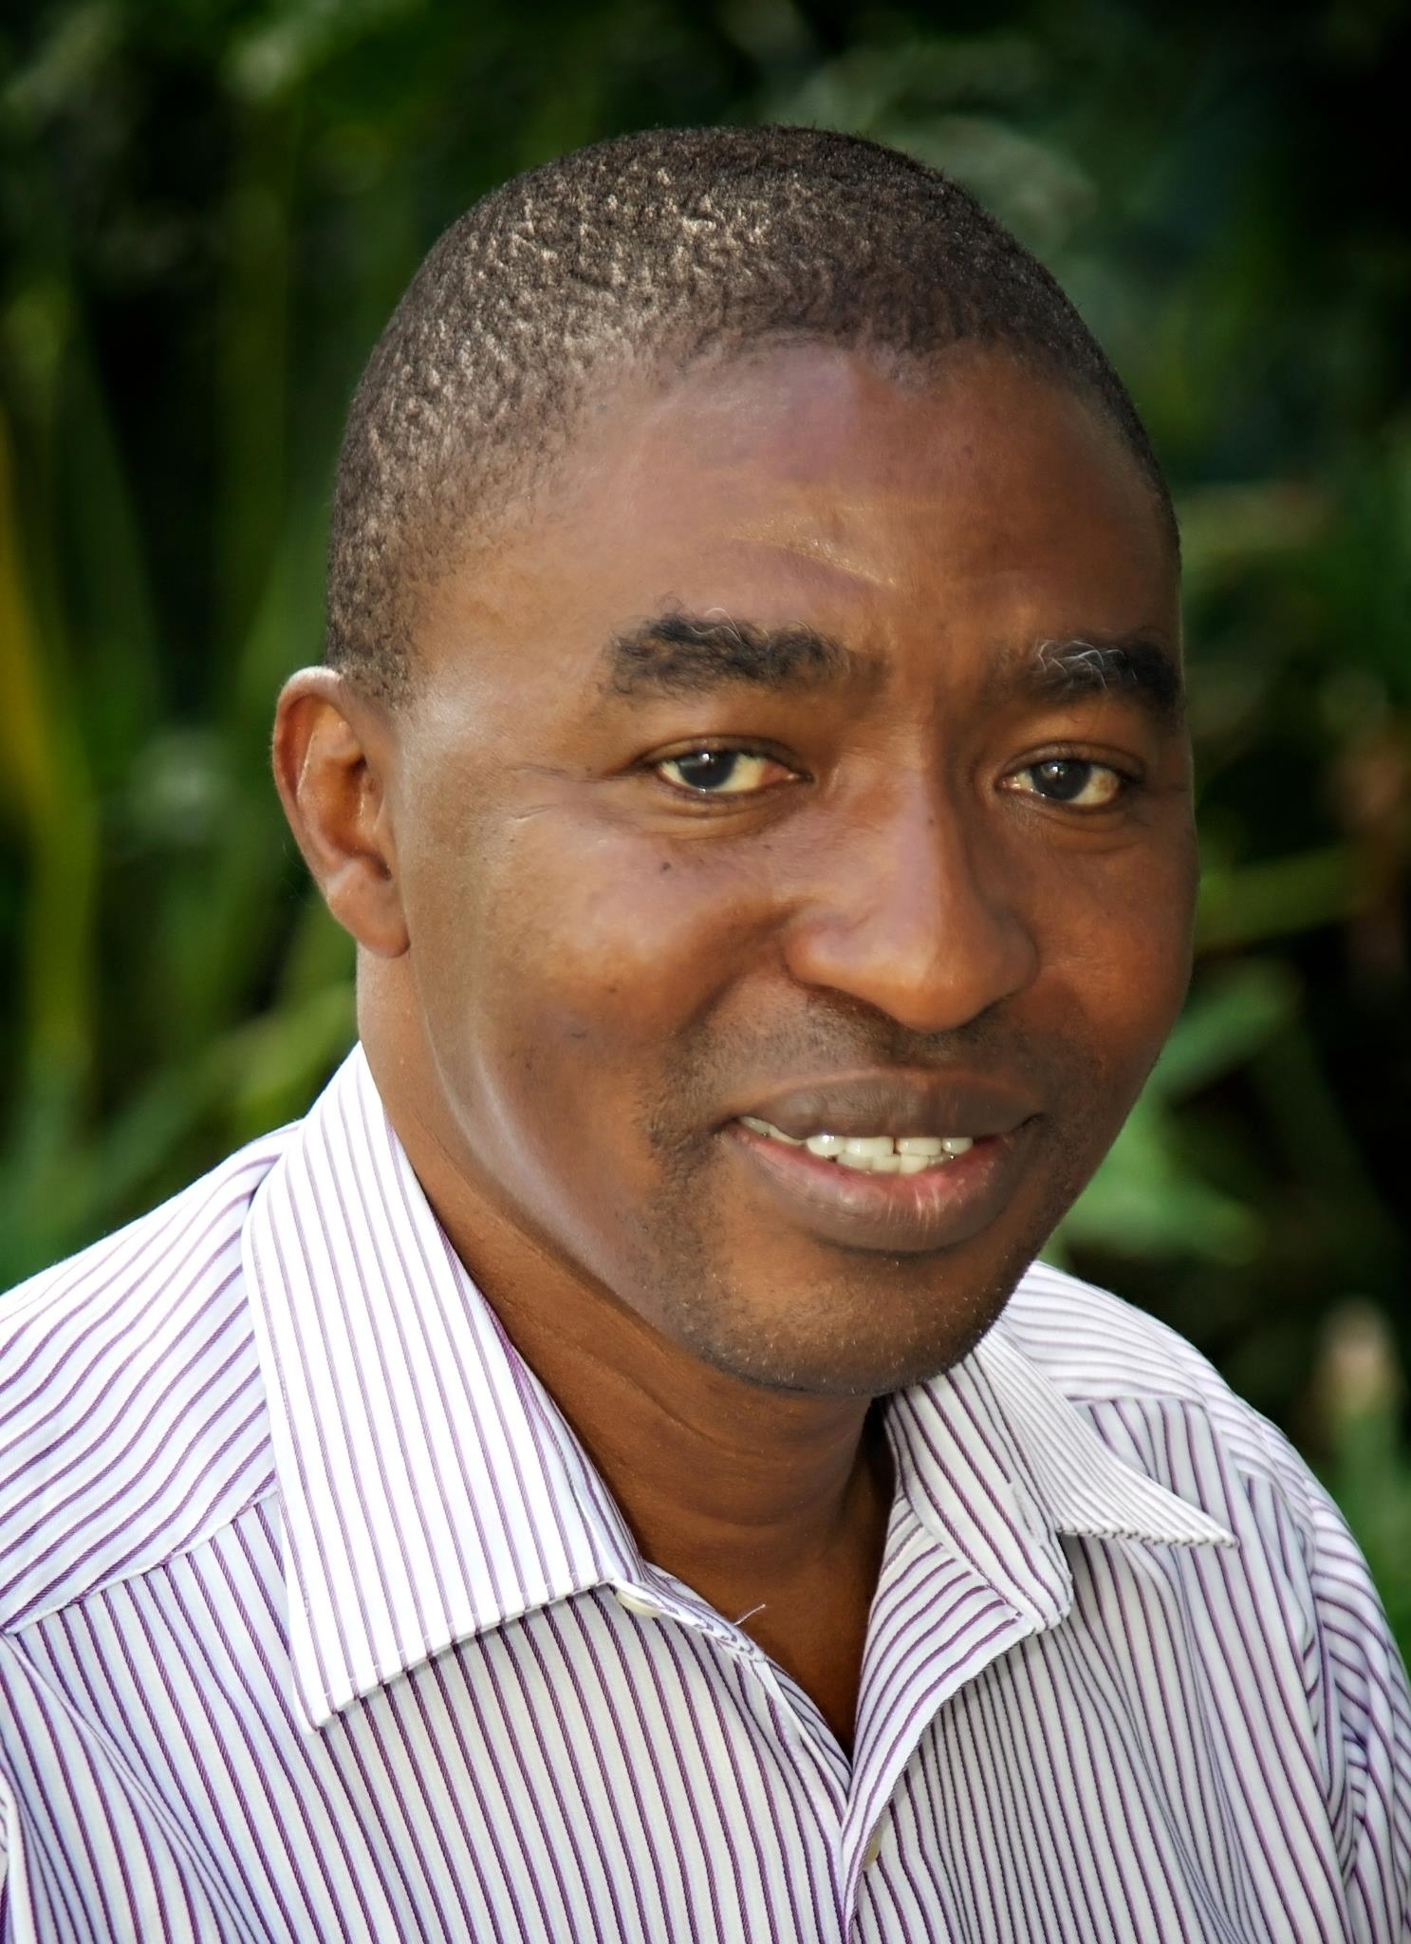
2.2.3.3. Dr. JOHN JUSU, (Sierre Leone, living in Kenya), Curriculum Director, Chief Curriculum Architect, Senior Consulting Coach
When Dr. John Jusu, MMD-G Senior Curriculum Architect and Course Editor, was tasked to coach PTI, he realizes that PTI was failing to complete the courses which it has set out to. It transpired to John that this challenge was coming because of lack of context analysis. Who were these courses being written for? What their situation? The problem was that PTI was developing its courses at BTh level but targeting grass root pastors. His observation was that courses were not marching up with the context of its learners and that PTI needed to think of a better curriculum which would address the context in which they were writing their courses for.

2.2.3.4. Richard Morris (Britain, living in USA), MMD-G Coach and Consultant
Richard Morris was requested to review AS’s curriculum. His observation was that AS’s curriculum was more informational than transformational in its approach. He developed a team comprising of John Jusu, Victor Lonu and Alpheus Banda to work with AS on a project that was aimed at training its educational coordinators in ARA learning responses. A number of training workshops were designed to help AS leadership to understand the concept of ARA learning responses. In one of the meetings in Nairobi, it was observed that AS leaders had noted that their curriculum using was not effectively bringing about the transformation which it intends. So the leadership was looking for something new that brings about the changes which they envision in their ministry. After this workshop, Richard proposed to the leadership of MMD-G for an ARA curriculum that focuses on grass roots which other partners like AS can model. A consensus was made by the leadership to conduct a situation analysis that will inform the development of the curriculum. In April, 2016, approval was made by MMD-G leadership to carry out a research to profile the grass root pastor’s situation. In the following month, May 2016, a research was conducted in Tala (Kenya), Burnia (Congo) and Salima (Malawi) by Victor and Alpheus which was a basis for this project.
Richard’s Potrait

3.0. THE CURRICULUM DEVELOPMENT PROJECT

3.1. Composition of the Team
A team of ten people met in June in Nairobi to reflect on the research results. It analyzed data from the research and developed and came up with a situation profile of a grass root pastor. Who is this pastor? What are his needs and how can they be addressed? were among some of the questions which were analyzed. Janice Muchai, for MMD-G staff and Peter Mathenge, Africa Services National Training Coordinator, Kenya were invited to contribute the development of the process.

3.2. The Process
The grass root curriculum development project took into account all processes in course and curriculum development namely contextual analysis, development of curriculum, testing, and editing. An additional training system plan for expanding a pool of facilitators was also designed. The whole process was as follows:

3.2.1. Context Analysis
Context analysis was the first process in this project. It involved profiling the situation as discussed. A participatory survey was conducted with 60 grass root pastors in Congo, Kenya and Malawi. The survey solicited information relating the pastors’ education, income, ministry among others (See Appendix???). Some of the key findings were as follows:
First, the survey found out that grass root pastors minister in the most hard to reach rural areas and among the most unreached groups. It also found out that besides church responsibilities, grass root pastors are also involved in community affairs and most of the challenges which they face relates to spiritual, economic and social well being of their families, congregations and self.
Second, the survey found out that grassroots pastor see ministry as a calling and their primary source of support is personal devotion to Christ and prayer. Although they are motivated to receive training related to ministry, but due to their geographic isolation, they do not receive most training opportunities.
Third, it was found that if they want to train others for ministry, they train them through involving them in church activities. However, most of the people are not willing to be trained for ministry. They expect their pastors to be available for them for twenty four seven (every day and every week) meeting their needs. Pastors who succumb to this pressure become overworked to the point of neglecting their personal wellbeing and that of their families. Many reported that church members were negative, disobedient, unwilling to become disciples, and that elders were uncooperative sometimes to the point of not accepting the pastor’s leadership. Other pastors said that their church members live great distances apart, which, coupled with the lack of resources for ministry and the lack of personal transport, handicapped their ability to minister effectively to their congregation’s needs.

Fourth, grassroots pastors frequently live in poverty without sufficient funds to pay their children’s school fees or family health care, and they daily struggle to sustain their family. In addition, they are expected to provide hospitality both to travelers and to visiting congregants. Other than farming, time spent to earn extra income is viewed negatively, even though the income from the church is as little as $5 to 10 per month. The congregation sees poverty and suffering as spiritual disciplines that are part of the call, so there is little concern to financially sustain them.
Fifth, most of the grass root pastors do not have salary. For example, in DRC, one in ten pastors reported that the church was taking care of them. Pastors could have a second income in some rural areas of Kenya. In Burundi, the pastor is offered the very best that the members have when he visits (Sunday through Thursday).
Sixth, most pastors have completed primary education and very few have a bachelors’ (high school) degree. Very few also have post-secondary training. Their church members’ education experience is usually, lower but spans the range from illiterate to secondary (high school) graduates. Additionally, most of their members do not own a bible or know how to read it.
Seven, many denominations’ mandate is that pastors move every one to three years from one congregation (station) to another. This makes it difficult for them to establish a vibrant disciple-making ministry within the Church as relationships between pastors and members keep on changing because of these movements. Others spend long periods apart from their family because they do not want move them from place to place so frequently. Some have a feeling that their church hierarchy is insensitive to their situation. In contrast, some of the pastors from more established denominations exercise authority over their elders, sometimes to the point of lording over them.
Eight, financial stress, demanding work hours, and frequent separation with their spouses lead to pastors serving without the full support of their spouses and family. In addition, the lack of love between church members, misunderstandings and divisions within the church, conflicts between denominations and the unrealistic expectations of members about pastoral duties also impact some pastors to the point that they serve with bitterness.

3.2. 2. Development of the Curriculum
Alpheus and Victor met from June 29th to July 2nd in Nairobi for next seven days to design an ARA curriculum for grass root pastors called the life and calling of a pastor. The mode of delivery for this curriculum was designed to be an extended seminar with 3 days of seminar workshops and 3 months of post seminar assignments. The delivery of the curriculum was designed to take 9 to 12 months. The curriculum was edited and reviewed by the other team members in July before pre-testing it.

3.2.3. Pre-testing
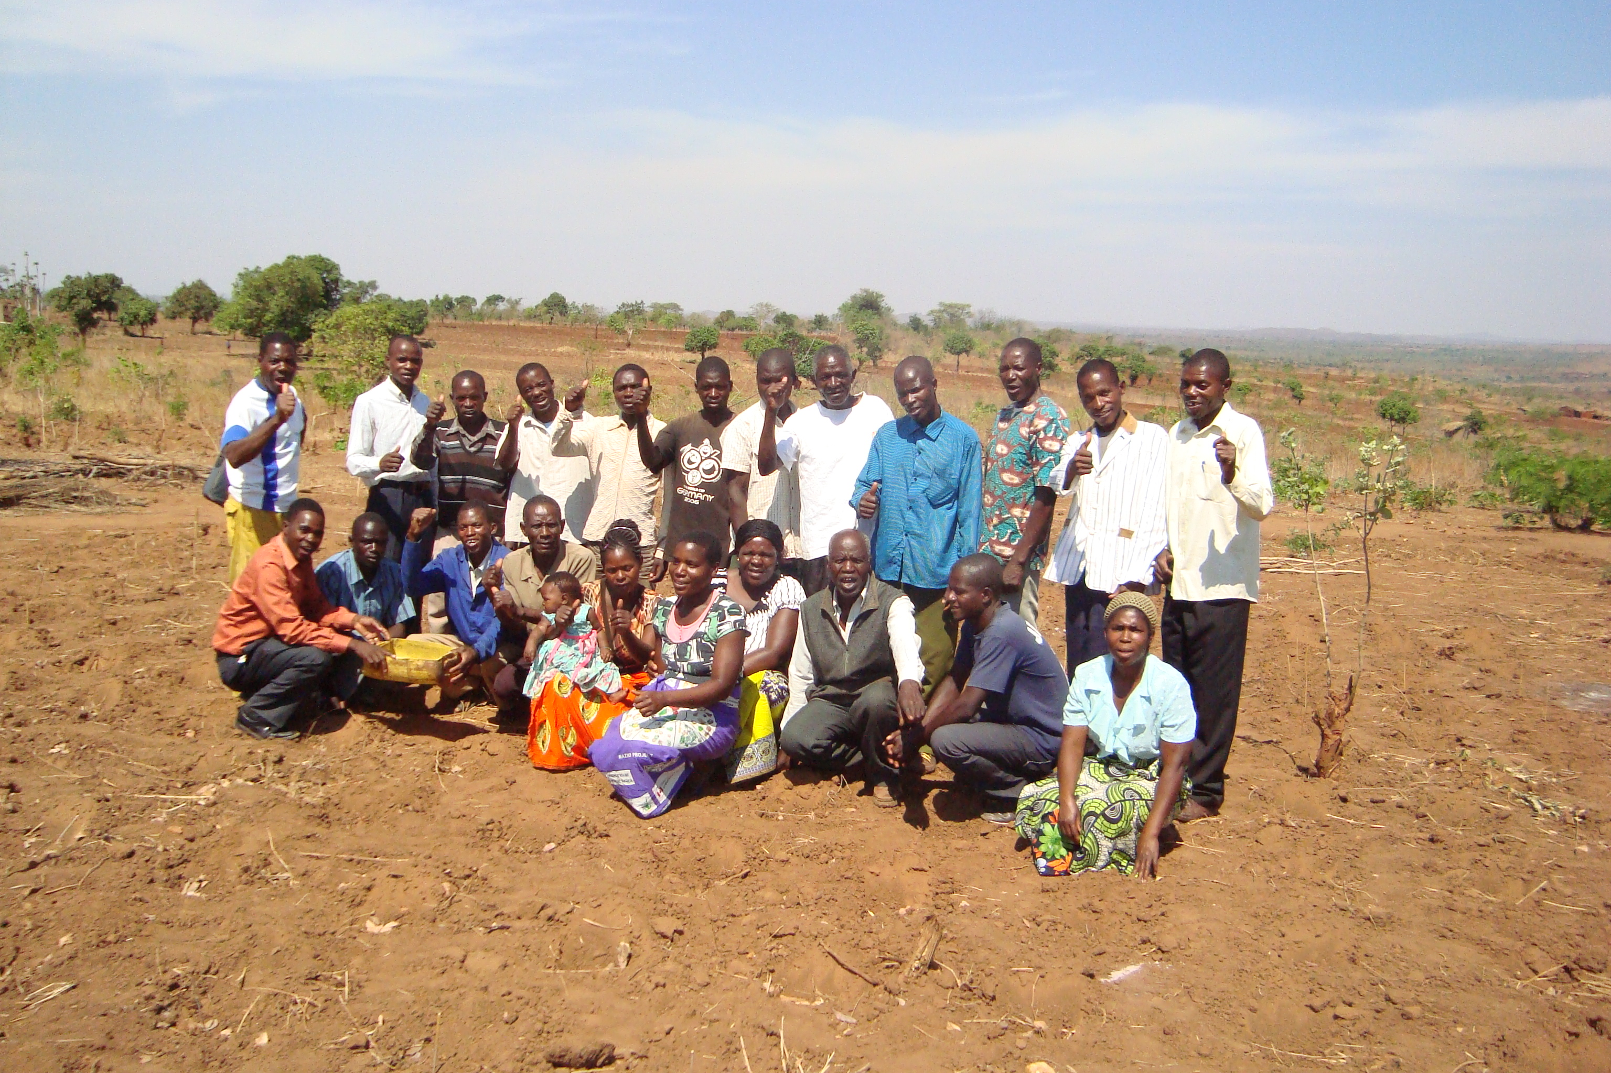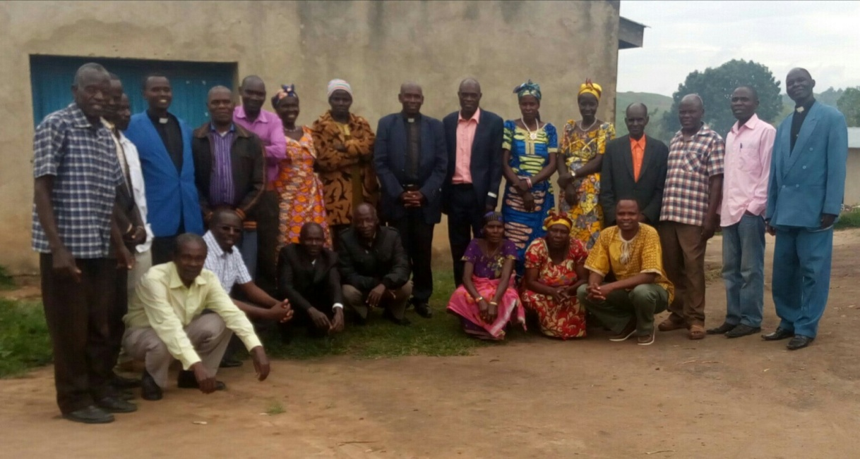Participants in Malawi (Pic 1) Participants in Congo (Pic 2)
The curriculum was pre-tested in Kenya, Congo and Malawi from August 2016. A total of 60 grass root pastors and church leaders participated as follows:
- Kenya: Kangundo, August, 2016 to July 2017
- Congo: Mandro, August 2016 to July 2017
- Malawi: Kasungu, November 2016 to October 2017.

3.2.4. Editing and Revision
The curriculum was reviewed based on the finding from the pre-testing. A final draft curriculum was completed in March, 2018 in Nairobi.

3.2.5. Facilitators Training
Facilitation training for grass root pastors was conducted in Malawi. The pastors are successfully facilitating ARA grass root learning responses among their congregations and communities.

3.2.6. Impact Evaluation
A summative evaluation study was conducted in Congo, Kenya and Malawi. The survey was aimed at ascertaining the impact of the grass root learning response. Findings of this study are found in section 3.2.

3.2.6.1. Purpose of the Evaluation
An impact evaluation was conducted at the learning response in the three targeted communities. This was a summative evaluation and its purposes were as follows:
- To assess if the intended outputs and outcomes of the learning response were attained among the target communities
- To determine the relevance, effectiveness, impact and sustainability of the response both from a level A (MMD-G) and level C (partners) perspective.
- To determine the most significant changes in the lives of people and their communities and how the response has contributed towards the changes.
- To document best practices and draw lessons that will used by MMD-G and other stakeholders in the design and implementation of future similar projects.

3.2.6.2. Scope of the Evaluation
The scope of the evaluation was to assess the impact of the grass root learning response on the life and calling of a pastor. It solicited changes in the participants’ knowledge, attitudes and practices related balancing their obligation to family, ministry as a result of the learning response. These changes were solicited through the following achievement based objectives.

By the end of the learning response, grass root pastors will have started to:
- Meet the needs of their families
- Equip other people in their congregations for ministry
- Build rhythm of with their selves and calling
- Practice ways for equipping others in a balanced ministry life (2 Tim 2:2).

3.2.6.3. Methodology
The study was evaluative in nature using both quantitative and qualitative data. It assessed the changes which have occurred related to pastor’s effectiveness in (a) meeting family needs, (b) equipping others for ministry and (c) building rhythm with self. The study used both participatory approaches and desk reviews of reports documented in the course of implementing the project to gather its findings. A questionnaire was formulated which required participants to respond to a number of statements on a Likert scale related to their observations on changes which have occurred in their families, ministries and lives as a result of the learning response. Their responses were examined both quantitatively and qualitatively against the above variables.
Two things were done to avoid significant errors. First, the questionnaire was shared among the team of consultants in section 4.0 above to provide their independent opinion on questionnaire. Second, a pilot test was conducted in Malawi to verify its reliability and validity.

3.2.6.4. Sample Size
A random sample size of 41 people (68%) was selected in the three test locations. Table below shows number of people who participated in the evaluation in Congo, Kenya and Malawi

Table 3.2.6.4 Number of people who participated in the survey

No | Country | Total Number of People
1 | Congo | 16
2 | Kenya | 14
3 | Malawi | 11
 | TOTAL | 41

Table 3.2.6.4 Number of people who participated in the Survey and their roles in Kenya
Number | Workshops Attended | Age | Sex 0=M 1=F | Years pastor | Roles
KR 01 | 2 | 57 | 1 | 21 | Pastor
KR 02 | 1 | 63 | 1 | 13 | Pastor
KR 03 | 4 | 46 | 0 | 18 | Lead Pastor
KR 04 | 3 | 36 | 1 | 7 | Lead Pastor
KR 05 | 2 | 49 | 1 | 5 | Lead Pastor
KR 06 | 2 | 40 | 1 | 13 | Pastor
KR 07 | 2 | 47 | 0 | 23 | Pastor
KR 08 | 3 | 57 | 0 |  | Pastor
KR 09 | 4 | 45 | 0 | 20 | Pastor
KR 10 | 3 | 66 | 0 | 10 | Pastor
KR 11 | 2 | 50 | 0 | 5 | Pastor
KR 12 | 3 | 40 | 0 | 10 | Pastor
KR 13 | 3 | 44 | 0 | 3 | Pastor
KR 14 | 4 | 48 | 0 | 17 | Pastor
Averages | 2.7 | 49 | 69% Men (11/16) | 13 | 100% pastors 14/14

Table 3.2.6.4 Number of people who participated in the survey and their roles in Congo

Number/ID | Workshops Attended | Age | Sex 0=M 1=F | Years pastor | Roles
MR 01 | No data | No data | No data | No data | Pastor
MR 02 | No data | No data | No data | No data | No data
MR 03 | No data | No data | No data | No data | No data
MR 04 | No data | No data | No data | No data | No data
MR 05 | No data | No data | No data | No data | No data
MR 06 | No data | No data | No data | No data | No data
MR 07 | No data | No data | No data | No data | Pastor
MR 08 | No data | No data | No data | No data | No data
MR 09 | No data | No data | No data | No data | No data
MR 10 | No data | No data | No data | No data | Pastor
MR 11 | No data | No data | No data | No data | Pastor
MR 12 | No data | No data | No data | No data | No data
MR 13 | No data | No data | No data | No data | No data
MR 15 | No data | No data | No data | No data | Pastor
MR 16 | No data | No data | No data | No data | Pastor
Averages |  |  |  |  | 40% pastors 6/15

Table 3.2.6.4 Number of people who participated in the survey and their roles in Malawi

ID/Number | Workshops Attended | Age | Sex 0=M 1=F | Years pastor | Roles
KA1 | 3 | 69 | 0 |  | Member
KA2 | 3 | 25 | 1 |  | Elder, Tres
KA3 | 3 | 36 | 0 | 5 | Sr pastor
KA4 | 1 | 37 | 0 | 8 | Sr Pastor
KA5 | 4 | 33 | 0 | 1 | Sr pastor
KA6 | 3 | 60 | 0 | 10 | Sr pastor
KA7 | 4 | 38 | 0 | 10 | Sr pastor
KA8 | 3 | 30 | 0 |  | Secretary
KA9 | 3 | 40 | 0 |  | Youth Chairperson
KA10 | 4 | 34 | 1 |  | Church Admin
KA11 | 3 | 37 | 1 | 18 | P's wife
Averages | 3.1 | 40 | 72% male 8/11 | 9 | 54% pastors 6/11

3.2.6.5. Limitations
The major limitation to the survey was translation. Questionnaires were in English and the interviews were conducted in the local languages of the targeted groups. It may be that the numerators did not translate some of the concepts into vernacular properly. This may have led to respondents not answering the questions properly or giving out the wrong information.

4.0. FINDINGS AND IMPACT OF THE PROJECT

4.1. Quantitative Findings on Impact of the Project
The findings and quantification of project impact on each outcome were as follows:

4.1.1. Pastor Meeting the Needs of his or her Family (children and wife)
Four (4) variables relating to pastors’ family needs were tested as follows: (a) financial needs; (b) emotional needs; (c) spiritual needs; (d) spouse relational needs. Using one of the five Likert scale responses, respondents were asked choose an answer relating to their attitude towards meeting the needs of their families before and after the training. Each Likert scale response was given a score as follows: “Strongly Disagree (1)”, “Disagree (2)”, “Agree (3)”, “Strongly Agree (4)” before and after the training. Table 6.1.1 shows the average response for each variable.

Table 4.1.1 Participants Perceptions towards meeting their family needs

RESPONSE | Financial Needs | Emotional Needs | Spiritual Needs | Spouse's Concerns
BEFORE | 2.3 | 2.3 | 2.4 | 2.5
AFTER | 3.3 | 3.4 | 3.5 | 3.4

Table 6.1.1 shows that pastors were not meeting their family needs before the learning response. This is because the average score of pastors on meeting the needs of their families before the training is less than 3. This represents that they had disagreed with a statement that pastors were meeting the need of their families before the training. This is also illustrated in the chart 6.1.1 below.

Chart 4.1.1 General Observation of Pastors meeting the needs of their families

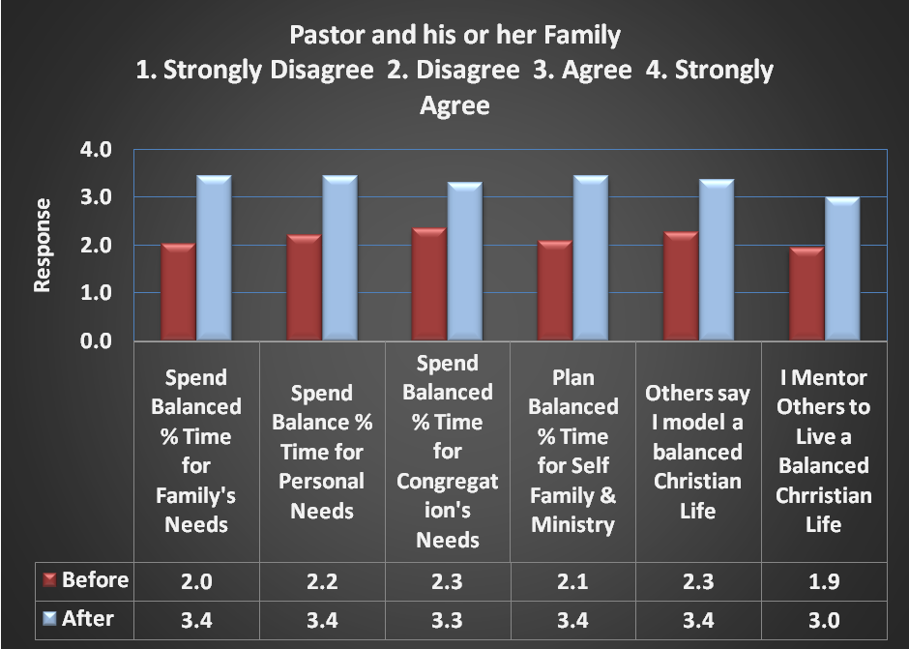

Table 4.1.2 Pastor and Family

Response | Pastors Meeting their Family Needs
Response | Before |  |  | After
Response | Disagree | Agree | Error | Disagree | Agree | Error
Financial | 24  (60%) | 16  (40%) | 0  (0%) | 5  (13%) | 34  (85%) | 1  (2%)
Emotion | 22  (55%) | 16  (40%) | 2  (5%) | 2  (5%) | 36  (90%) | 2  (5%)
Spiritual | 18  (45%) | 18  (45%) | 0  (0%) | 0  (0%) | 36  (90%) | 4  (10%)
Spouse | 16  (40%) | 22  (55%) | 2  (5%) | 4  (10%) | 32  (80%) | 4  (10%)

Table 4.1.2.1 indicates observations from each tested variable on pastor and his or her family. It shows that before the training only 40% of the participants were meeting the needs of their families financially before the training while 85% started meeting financial needs of their families after the training the training. 40% were meeting the emotional needs of their families before the training and after the training 90% were meeting emotional needs of their families. 45% were meeting spiritual needs of their families before the training while 90% were meeting the spiritual needs of their families after the training. Only 55% were meeting the needs of their spouses before while after the training 80% of the participants were meeting the needs of their spouses. Chart below shows percentage of people who were meeting the needs of their families after the training.

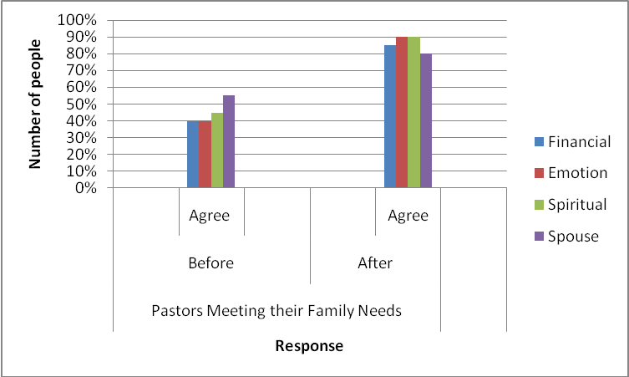

4.1.2. Pastor equipping other people in their congregations for ministry
Five (5) variables were used to test pastors’ knowledge, attitude and practice towards equipping members of their congregations for effectiveness in ministry as follows: (a) pastors’ understanding of the biblical worldview of a local Church in a community; (b) pastors’ attitude towards evaluating the impact of his or her local Church in the community; (c) pastors’ ability to make plans for equipping members of their congregations for effectiveness in ministry; (d) pastors’ ability towards preparing others for ministry; (e) pastor’s ability in delegating others for ministry. Using the five Likert scale responses, respondents were asked choose an answer relating to their knowledge, attitude and practice towards equipping members of their congregations for ministry before and after the training. Each Likert scale response was given a score as follows: “Strongly Disagree (1)”, “Disagree (2)”, “Agree (3)”, “Strongly Agree (4).” Table 6.1.2 shows average response on pastors’ equipping their congregations for ministry before and after the training.

Table 4.1.2.1 Pastors attitude towards the equipping others for ministry needs
PASTOR AND CONGREGATION
RESPONSE | Bib under of Loc Church | Evaluated Impact of Loc | Plan for Equipping Saints | Prep Saints in Ministry | Delegate Resp
BEFORE | 2.1 | 1.9 | 2.3 | 2.4 | 2.4
AFTER | 3.4 | 3.4 | 3.4 | 3.2 | 3.3

Table 4.1.2 shows that most pastors were not equipping members of their congregations effectively for ministry before the training. This is because the average score on Likert scale relating to their knowledge, attitude and practice towards equipping members of their congregations before the training was less than 3. This means that they disagreed that they were effectively preparing members of their congregations for ministry before the training. Chart 6.2.1 and Table 6.2.2 below shows this argument clearly.

Chart 4.1.2. Pastors perceptions towards equipping some people in their congregations for ministry.
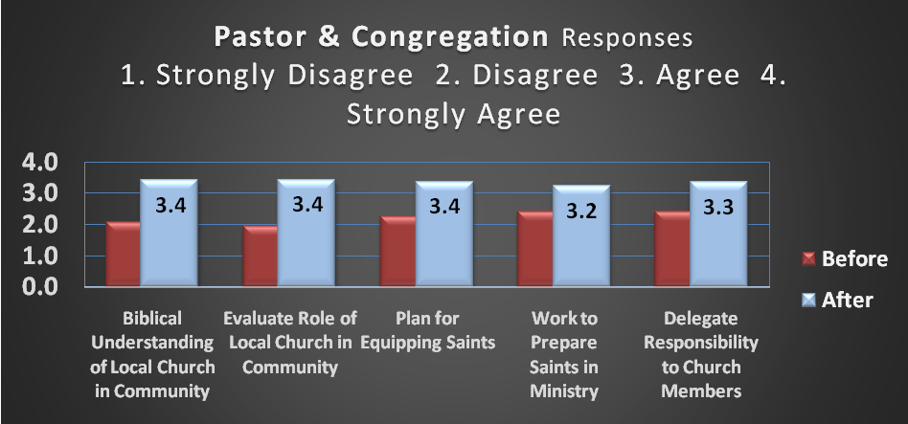

Table 4.1.2.2 Pastors perceptions towards equipping some members of their congregations for ministry.

Response | Pastors Meeting their Family Needs
Response | Before |  |  | After
Response | Disagree | Agree | Error/NR | Disagree | Agree | Error/ NR
Understands the Biblical worldview of a local Church in community | 23  58% | 11  28% | 6  14% | 3  8% | 31  78% | 6  14%
Evaluates the impact that his local Church in making in community | 26  65% | 10  25% | 4  10% | 1  2% | 35  88% | 4  10%
Has plans for equipping other people in his/her Church for ministry | 24  60% | 12  30% | 4  10% | 4  10% | 32  80% | 4  10%
Prepares others for ministry | 19  48% | 16  40% | 5  13% | 4  10% | 31  78% | 5  13%
Delegates responsibilities to others in his/her Church | 17  43% | 18  45% | 5  13% | 5  13% | 30  75% | 5  13%

Table 4.1.2.2 indicates that before the training 28% (11) of the pastors had a good understanding of a Biblical worldview of a local Church in a community while after the training 78% (31) had. There was an error of 14% (6). 25% (10) were evaluating the impact of their local Churches in community and improving on their responses towards it before the training while 88% (35) were after the training. There was an error of 10% (4). 30% (12) had plans for equipping other members of their congregations for effectiveness in ministry before the training while 80% (32) had after the training. There was an error of 10%. 40% (16) were preparing others for effectiveness in ministry before the training while 78% (31) were after the training. There was an error of 13% (5). 45% (18) were delegating responsibilities to others in their congregations before the training while 75% (30) were after the training. There was an error of 13% (5). Chart 6.2.2 below shows the above response clearly.

Graph 4.1.2.2 Pastors perceptions towards equipping others for effectiveness in ministry
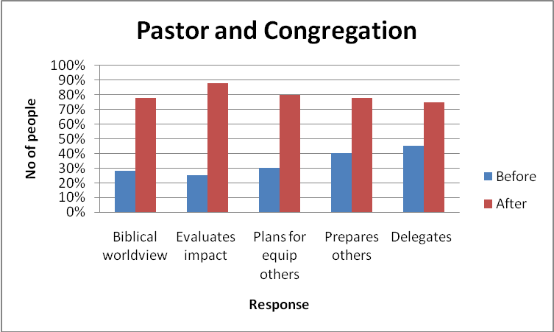

4.1.3.0. Build rhythm with self, family and ministry
Five (5) variables were used to test how the pastors live a balanced life with family, ministry before and after the training. The variables were as follows: (a) spends balanced time for family needs; (b) spends balanced time for personal needs; (c) spends balanced time for congregation’s needs; (d) spends balanced time for self, family and ministry all together consistently; (e) model a balanced Christian life (for family, congregation and self). Using the five statements on Likert scale, respondents were asked choose an answer that relates well to their attitude and practice towards building a rhythm with self, family and ministry before and after the training. The scores were as follows: “Strongly Disagree (1)”, “Disagree (2)”, “Agree (3)”, “Strongly Agree (4).” Figure 6.3.1 shows the average responses of participants.

Figure 4.1.3.1. Participants Averages on living a balanced time self, family and ministry

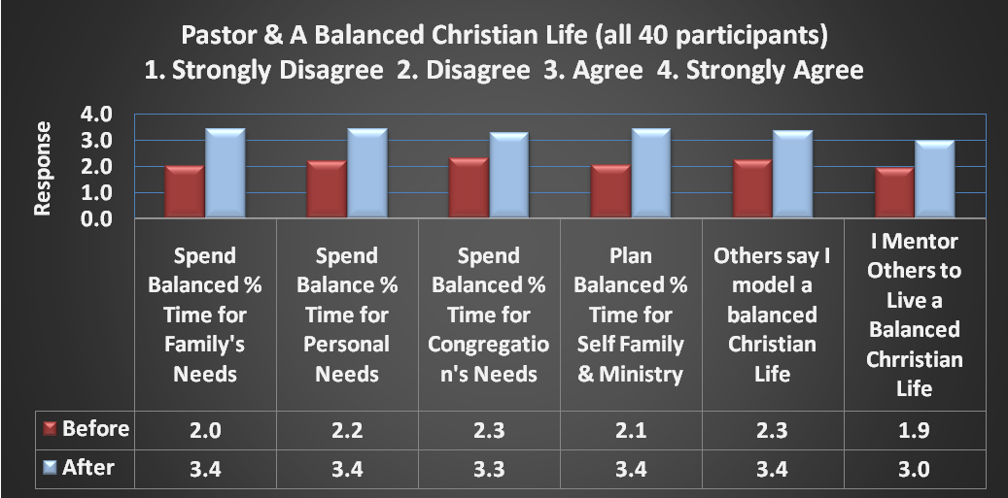

Table 4.1.3.1 Pastors attitudes towards building rhythm with self, family and congregation.

Response | Pastors living a Balanced Life
Response | Before |  |  | After
Response | Disagree | Agree | Error/NR | Disagree | Agree | Error/ NR
Time for family needs | 26  65% | 11  28% | 3  8% | 3  8% | 34  85% | 3  8%
Time for personal needs | 23  58% | 11  35% | 3  8% | 0  0% | 39  93% | 3  8%
Time for congregation’s needs | 24  60% | 13  33% | 3  8% | 1  3% | 35  90% | 3  8%
Balanced time for self, family & ministry | 26  65% | 11  28% | 3  8% | 0  0% | 36  90% | 4  10%
Model a balanced Christian life | 23  58% | 14  35% | 3  8% | 2  5% | 35  80% | 3  8%

Table 4.1.3.1 indicates that before the training 28% (11) of the pastors were spending balanced time for their family needs while after the training 85% (34) were. There was an error among 8% (3) of them. 35% (11) were spending balanced time for their personal needs before the training while 93% (39) were after the training. There was an error of 8% (3). 33% (11) were spending balanced time for congregation’s needs before the training while 90% (35) were after the training. There was an error of 8% (3). 28% (11) were spending balanced time for family, congregation and self consistently before the training while 90% (30) were after the training. There was an error of 10% (4). Finally, 35% (14) modeled a balanced Christian life for family, ministry and self in their communities while 80% (35) did - others said that they did. There was an error of 8% (3). Figure 6.3.2 below shows the above results clearly.

Figure 4.1.3.2. Pastor and Balanced Christian Life with Family, Congregation and Personal Needs.

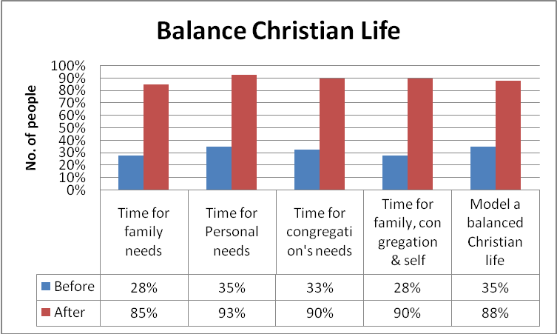

4.2.0. Qualitative Findings and Impact of the Project.
There are three elements of our work (inputs) as MMD-G with partners. These include consulting, training and coaching. When looking at our impact chain, we do not only consider what we do as agents of change (inputs) but also the results (impact). Rather than reporting on the number of people or workshops conducted (as discussed in section 6.1), we are also interested in knowing the impact of our inputs on the ministries or individual we are training and the eventual impact on the communities or family served by these ministries or individuals respectively. of impact. Thus, our analysis of impact is measured in three levels as follows: direct, ministry and community impact. Since in this project we were not necessarily working with individual ministries but individual persons, our direct impact relates to the impact on the individual, ministry impact relates to the impact on the family and community impact relates to the impact on the congregation. A number of variable were used to measure the impact on the above levels. Table 6.2.1 shows a list of variable which were used on each level.

Table 4.2.1 List of Variables Used to Measure the Impact

Project aim and what we did | Direct Impact (of what we did on individual/ participants) | Ministry Response Impact (of what the partner did in the family and congregation) | Community Impact (of what happened as a result of what the partner did in the family and congregation)
- Training on L&CP  - ARA Extended Seminars  - Profiling situations on pastors family, congregation and self.  - Facilitation Workshop. | - Did participants change their perspective on training?  - Did the trainers complete a situation profile in their context?  - Did trainers demonstrate a change from presenting content to facilitating learner discovery? | - Did the trainers develop responses that brought biblical transformation to their families, congregations and self?  - Did the trainers implement this training in their communities? | - Is the pilot implementation producing measurable change in the situations addressed to date?

The goal of the present project was to equip grass root pastors with skills to bring transformation into their situation by balancing their obligations to family, ministry and calling. To achieve this aim, ARA extended seminars and profiling of above situations were conducted. Finally, a facilitation workshop was conducted to give the participants skills and knowledge to facilitate ARA seminars in their communities and congregations. The following are the recorded impact of the response.

4.2.1. Direct Impact (Impact on the Individual)
In measuring the direct impact of the project on individuals, we sought to find out what happened to the participants as a result of the training. It was discovered that at individual level, most of the participants had changed their perspective regarding challenges which they were facing related to their life and calling. They managed to complete all situation profiles of their context (family, ministry and self) and through it discovered new ways of addressing their discouraging situations. For example, many of them agreed that before the training they were not meeting the needs of their families effectively but after the training were able to meet their family need effectively (refer to table 6.1.1.2). Similarly they did the same with their congregation’s and personal needs. They discovered better ways of supporting their families, congregations and met their own needs. For example, Mrs Kanyali, a pastor wife said that for the first time in her 20 years of marriage she now has enough food to feed her family of eight people throughout the whole year (April 2017 to March 2018). “I have harvested 60 bags of maize (3 tonnes). This is the first time in my life. The largest amount that I have had was 20 bags (1 tonne) after learning how to take care of my family using low cost methods from seminar I.” She stared narrating her story.
“In 2016, my family had challenges with food. We had no money to buy fertilizer and as result we failed to harvest enough to feed our children throughout the year. But from Seminar I, I learnt how to use low cost methods from locally available materials to make composite manure and apply it in my garden. I also learned Biblical principles on how to be a good steward of God’s creation by farming God’s way. After the seminar, my husband and I prepared our first maize garden as a demonstration garden. We made composite manure using cow dugs, ashes among other locally available materials. We also prepared two other gardens which we own as a family. After a period of time our gardens were looking better than the rest of the people in our community. I remember some people asking me and my husband what we have done. As I am speaking now, we have harvested 60 bags of maize. Out of them, we have given a tithe of six bags to the Lord. This is the first time in our 20 years of marriage to produce such an amount of food to feed our family. The largest number of bags that we have produced is 20 bags. This year, my family of eight will have enough food to eat throughout the year (2017). We will no longer fail to feed our children or beg for food.” She explained pointing us to go and see her bags of maize.
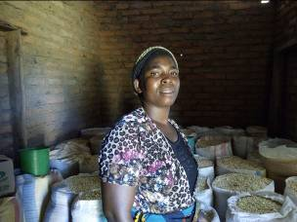
Mrs Kanyali standing in front of her bags of maize
Additionally, she started finding people in her area whom she would work with. She said that she found Mrs Mbewe, a Pastor’s wife, to share with her the changes and challenges that she was meeting in the course of implementing her assignments for seminar II. “I have found these meetings with Mrs Mbewe helpful,” she said. “It has contributed to building a good relationship between her family and mine although they go to a different Church than mine. We meet regularly. She invites my husband and I to preach in their Church and we invite her and her husband to also preach in our Church. This has been fruitful both to her ministry and ours.” She explained.
The same changes in Congo and Kenya which can be summed up as follow:
  - The participants were very excited and responsive to the changes which were happening to them through profiling their situations.
  - They discovered new ways on how challenges related to their life and calling as pastors in rural areas for them to be effective in the ministry.
  - Participants were very encouraged by the fact that the seminar brought together ministers from different church denominations. It was an opportunity for them to know each other creating an opportunity for them to work together and support one another.

4.2.2. Ministry Impact (Impact on the Family)
At ministry level, the training facilitated a biblical transformation of participants’ lives, families and congregations. For example, when one of the participants, Mr. Kosamu Mtonga aged 67, attended the first seminar in Malawi in 2016, he was a polygamous pastor pasturing of one of the African indigenous Churches which allows polygamous marriages. He was invited to the seminars simply because of his position as a pastor and members of the pastors group which the project was working with. After attending the first seminar, Pastor Kosamu says that he made a decision made a decision to stop going to his Church which allows polygamy. He decided to join one of the evangelical Churches in the area which held a Biblical view of marriage and Christian living. Something had happed in his life through seminar I which no one can explain. Through reflecting and acting on the Bible, it made him to change not only his perspective about marriage but also ministry. He decided to join this Church as a member only to learn from the Bible which was held as central authority for life in this Church. Although his wives did not follow him, Kosamu says that he started teaching them about the Bible and later on they also confessed Christ. As result, Mr Kosamu did not only discover a new relationship with Christ but also support his family to do the same. In Congo, one participant also decised to changed his church denomination and joined a Church which that holds the Bible as a centre of authority for life.
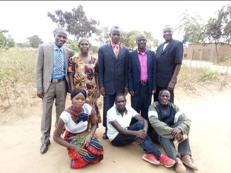
Mr. Kosamu sitting down 1st from the right
Additionally, Mr Kosamu also managed to implement the content which were facilitated in the training on Farming God’s Way (FGW). As a result, Mr Kosamu was able to produce enough food to feed his family. “From a small piece of maize garden (39mx19m), that I prepared, I have produced 12 bags of maize (600kgs).” He said. “This just from a demonstration garden but I had also applied the principles in my other gardens where I have produce enough to feed my family,” he added. On post seminar II assignments, this is what he said. “I managed to work with my three wives. My wives were not going to Church and this is the reason why I decided to work with them. I started sharing them God’s word and I am glad to inform you that as a result of it, they have accepted Christ and have started going to Church.

4.2.3. Community Impact (Impact on the Congregation)
At community level the project resulted into significant changes. For example, Pastor Kanyali from Malawi reported that the seminars changed his attitude towards support his family and congregation. “I used to think that as a Pastor, I should always be supported by the members of my congregation. But through these seminars, I am now able to support other people in my Church. He said. “Usually,” he added, “I was leaving my family alone and go to serve other people. I was very tough with my children and they would not be close to me but through these seminars I made a plan to work with them. I planned that I should close to my children, pray with them every night. Through this, my children have started to be close to me. They have also started praying for me.” He explained. Some of the key results at community and congregation level are as follows:

- Participants applying what they have learned. Majority practices FGW to improve their food security at household level.
- Pastor’s families and their members engaged in small scale business to improve their income.
- Participants involve their family members in decision making
- The worldview of many has changed. For example, one family in Congo started selling vegetables from their gardens and from it they bought pigs. After selling them, he bought a cow which they later sold it to buy a motorbike.
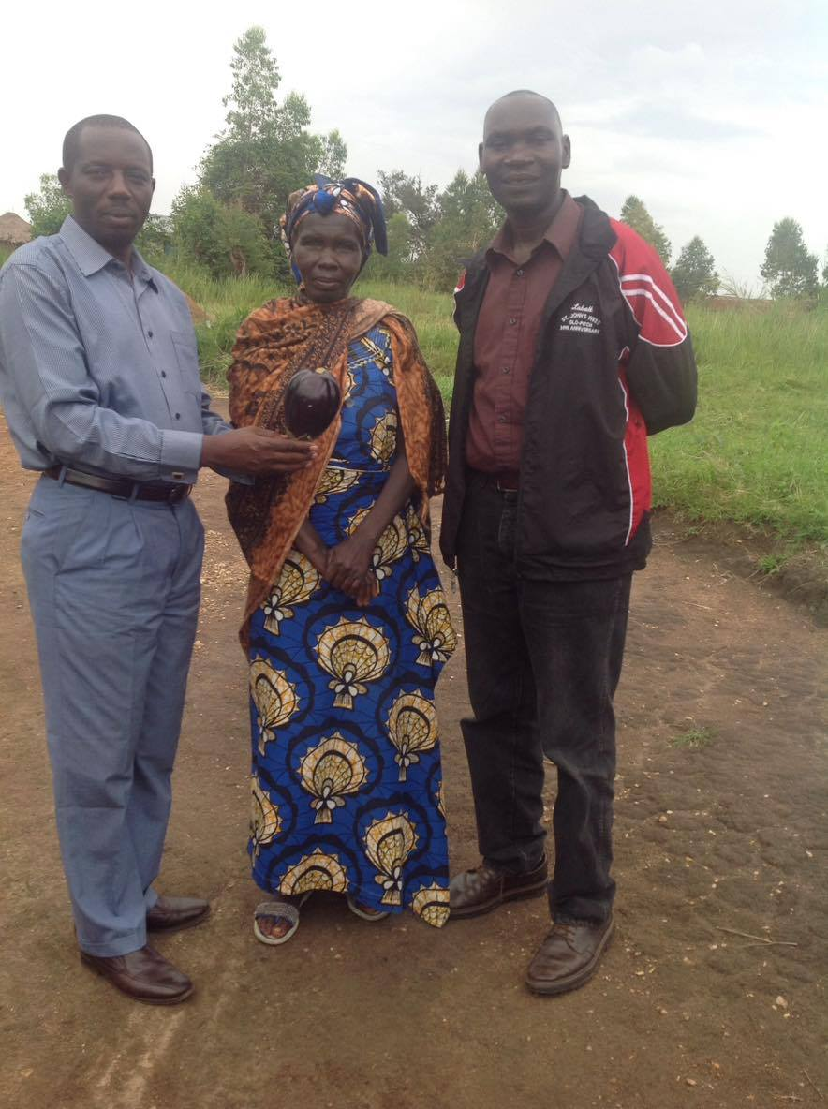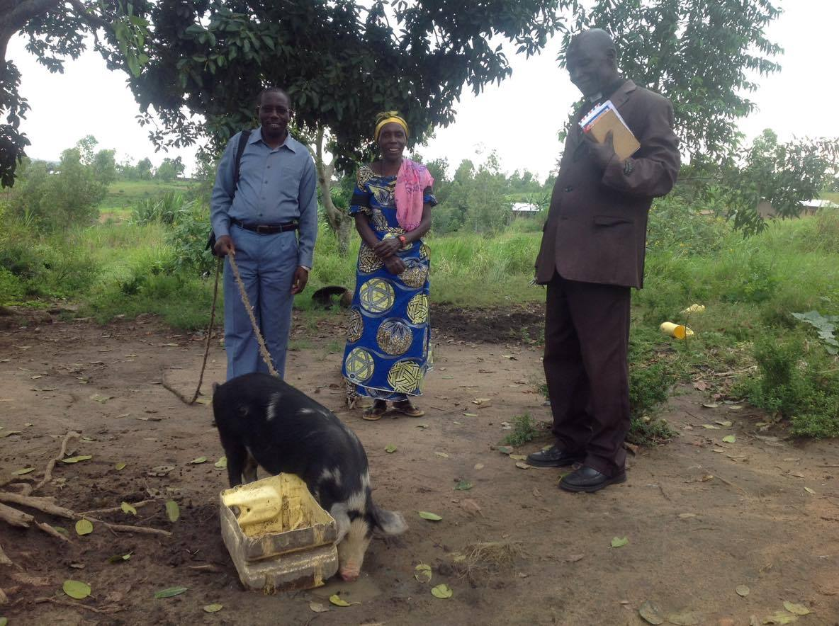
A family in Congo which change their livelihood as result of the seminars

5.0. LESSON LEARNT

5.1. The need for Grass root training programs in Africa Exists
First, the need for grass root training programs among churches and communities in Africa really exists. The project has confirmed that the need for grass root training programs exists. It was set out with a hypothesis assuming that the need exists and the findings of this project has confirmed it. The study has found out that though grass root pastors are serving among the most un reached groups of people in Africa, most of them live challenging lives which affect the welfare of their families, ministries and dignity. For example, the study has confirmed that about 45% of the grass root pastors are able to meet financial, spiritual and emotional welfare of their families, 28% understands the Biblical role of a local church in a community, 25% evaluates how their local churches are making impact in their communities, 30% have plans for equipping other people in their congregations for ministry, 45% prepares others for ministry and 45% delegates their responsibilities to others. It also reveals that 28% have time for their families, 33% have time for their congregations and 35% have time for self development. So what kind of a grass root church does this picture give us? Looking at these figures, one would conclude that is an inch deep, a church that needs capacity because its pastors are not capacitated. Therefore, it calls for MMD-G to begin to think strategically how it can help the grass root Church in Africa with its transformational learning responses. This calls us to our second lesson

5.2. There is need for ARA Curriculum (Transformational Learning Responses) for Grass root pastors and we can design them.
Second, the project has find out that there is a great need for ARA curriculum targeting grass root pastors within the current MMD-G curriculum. Grass root are in need of transformational learning responses. The situations in which they are in require such type of learning responses. And since most of them serve among the most unreached groups of people in Africa is ion the need for such responses are enormous if the entire Church in Africa is to grow deep. Interestingly, the project has also revealed that we in MMD-G can design and implement grass root learning responses which grass root Churches in Africa can use. Here, we have learnt that it is possible to design and implement these learning responses and deliver the same results which the BTh program can. We have also learnt that while the needs for grass pastors vary, these responses can be designed in a way that facilitates responses to the varying situations transforming them for effective ministry.

5.3. ARA grass root learning responses can be multiplied by building an effective incubation program in a country among grass root pastors.
Third, the project (study) has revealed that it is possible to multiply ARA grass root learning responses among grass root pastors. However, the study has shown that if we are to ARA grass root curriculum among grass root pastors, we need to building an effecting incubation program. The study has shown that in countries where an effective incubation was built, for example, in Malawi, the grass root pastors have taken up the role of leading and implementing the training program among their communities. In this regard, building an effective ARA grass root incubation program involved selecting and training a few as facilitators. The selection criteria we based on those pastors attended almost all the seminars, participate in almost all the assignments and demonstrated transformational experiences resulting from the training. Additionally, an ongoing coaching for the facilitators enabled the incubations programs to be effective. While in countries where this was not done (Kenya), the incubation program did not work out effectively.

6.0. RECOMMENDATIONS
We would to recommend the following to MMD-G
- Consider multiplying and incubating the grass root curriculum among its partners
- Extending the curriculum for pastors to use with church leaders and members as a means for addressing other situations which grass root pastors face. The congregation of a grass root pastor is, in itself, a situation which the pastor face which affect his or her effectiveness in ministry.
- Create a new curriculum on Farming God’s Way (FGW) to respond to other economic needs which grass root pastors face.
- Facilitate coaching and training for grass root pastors in the areas of their life and ministry. The evaluations shows that while many had improved their life and ministry through this training, others were lagging behind and hence the need for more training to empower those lagging behind in ministry.

7.0. OTHER GRASS ROOT PROGRAM GOALS BEYOND 2018
- Create other ARA learning responses with groups such as Open Doors.
- Create other ARA learning responses that use ARA to train rural pastors in Africa.
- Explore how to multiply the use of grass root learning responses from face-to-face workshops to other primary means of delivery such media tools, website, youtube, SD cards, social media and video-based training that needs little or no face-to-face involvement by our team.
- Develop learning response for rural pastors which uses oral learning methods.
- Integrate the MMD ARA philosophy and methodology into the development and delivery of training in Africa Services to strengthen the church to be agents of holistic transformation in their communities.
- Support PTI in their implementation of ARA in rural Burundi
.

APPENDANCES

Appendix 1: MMD-G Non-accredited Projects Plans

The five projects described below are aimed at fulfilling the 2017 MMD Non-accredited Strategy.

Project 1: Develop and Prove Extended Seminar Model
Purpose
- Create an ARA model that extends the seminar training model used by groups such as Open Doors.
- Create learning responses that use ARA to train rural pastors.

Milestones:
- Completed field testing of Modules 1-4
  - Modules 1-3 by April 15
  - Module 4 by July 30
- Completed manuals for Modules 1-4
  - Module 1 by April 15
  - Modules 2-3 by May 30
  - Module 4 by July 30
- Extended Seminar Model Described by July 30
- Completed internal review of outcomes by September 30
  - I am thinking that we want to have JJ (maybe have Elesinah and Andre involved) review the materials and evidences of transformation to validate that the process is indeed ARA and is achieving the desired transformational outcomes.

Project 2: Develop a Strategy and Tools to Multiply Use of “Life and Ministry of the Pastor”

Purpose

- Explore how to multiply the use of the four modules without the need for face-to-face workshops to be the primary means of delivery. In other words, how do we go viral.
- issues of facilitation, interviewing
- media tools website, youtube, SD cards, social media for feedback & questions
- Part of going viral is to have video-based training that needs little or no face-to-face involvement by our team

Milestones:
- Developed a Multiplication Strategy
- Built Supporting Tools
- Completed Phase 1 Implementation

Project 3: Develop Learning Responses for Rural Pastor to Equip His Church

Purpose

- Phase 2 learning response for rural pastors working with his oral church members

Milestones:
- Profiled the rural church member

Project 4: Support expansion of Open Doors adoption of ARA

Purpose
- Integrate the MMD ARA philosophy and methodology into the development and delivery of training in Africa Services to strengthen the church to be agents of holistic transformation in their communities.

Milestones:
- Each Country has plans for ARA adoption by May 15
  - These plans will be developed in the Cameroon and Ethiopia workshops April 24-May 12.
- Developed plans to Support OD/PTI Trainers by June 30
  - This will include plans for coaching, workshops, and tool development

I expect that this project will lead to multiple tasks for the team during the remainder of 2017

Project 5: Support PTI in their implementation of ARA in rural Burundi
Purpose
- Build capacities for grassroots church leaders in leadership, counseling, preaching and discipleship to empower the church in Burundi.
Milestones:
- PTI have created an action and resource plan

No further work on this project will continue until PTI have a completed plan.

Appendix 2: Chain of Impact from Projects–Definition & Measurement

There are three elements to our work with a partner ministry—consulting, training and coaching. The document is organized around these three elements. The chart below identifies in the first column what we do as agents of change. These are inputs. They lead to results. Rather than report only on the numbers of who attended workshops etc. we focus on the impact our inputs have had on the ministry we are training and the eventual impact on the communities served by this ministry.

Impacts are divided into three categories:
- Direct Impact: these have mostly to do with immediately observable changes in perspective and behavior.
- Ministry Impact: these come as the ministry takes what it has learned and started to apply it in their training programs, on a pilot basis.
- Community Impact: this is what we are ultimately looking for. Do we see community situations transformed by the training responses developed through our training and coaching? Our projects usually have a pilot phase so the impacts will initially be small. If successful, community impact should increase as more communities experience the new training approach and more training responses are developed.

Projects (their aims and what we did) | Direct Impact (of what we did) | Ministry Response Impact (of what the partner did) | Community Impact (of what happened as a result of what the partner did)
Consulting:  - Conducted an Appreciative Inquiry into current practices and a vision for improved outcomes.  - Determined areas where SRD can make a difference to current training programs  - Evaluated necessary conditions for moving forward with a project  - Developed a project proposal leading to a decision to proceed. | Consulting:  - Were clear areas identified where improved outcomes are desired or possible?  - Did the organization express a commitment to change training practices?  - Does the organization have the resources necessary to bring change or a plan to obtain the resources?  - Is there a plan to move forward together? | Consulting:  - Has the organization provided the necessary human resources for the project to proceed?  - Is there funding in place to sustain the project?  - Has the organization made the changes necessary for long-term sustainability of the new mode of training? | Consulting:  - Have ways of measuring impact been developed and tested?
Training:  - Workshop on profiling situations in which we shared the importance of profiling the community and learner situation.  - Workshop on Course or Extended Seminar development.  - Workshop on SRD facilitation. | Training:  - Did the trainers change their perspective on training?  - Did the trainers complete a situation profile in their context?  - Did the trainers make progress in developing a suitable learning response during the workshop?  - Did trainers demonstrate a change from presenting content to facilitating learner discovery? | Training:  - Did the trainers develop training that brings biblical solutions to community problems?  - Did the trainers implement this training in their communities? | Training:  - Is the pilot implementation producing measurable change in the situations addressed?
Coaching:  - Creating situation profile designs  - Supporting response development by a team.  - Team review meetings.  - Developing in-house coaches. | Coaching:  - Are trainers connecting regularly with coaches? | Coaching:  - Has a complete learning response been developed, reviewed, tested, evaluated, and updated?  - Is progress being made in developing new learning responses?  - Is competent facilitation the norm in training delivery?  - Do competent coaches exist in the organization? | Coaching:  - Were transformational outcomes achieved in the learners and communities trained by the partner ministry?

Bibliography
John Jusu, Educational Training and Consultancy, MMD-G, 2016
Alpheus Banda and Victor Lonu, Life and Calling of a Pastor, MMD-G, 2018
Alpheus Banda, Life and Calling of a Pastor, Seminar I Report, MMD-G, 2016
Alpheus Banda, Life and Calling of a Pastor, Seminar II Report, MMD-G, 2017
Victor Lonu, Life and Calling of a Pastor, Seminar I Report, MMD-G, 2016
Victor Lonu, Life and Calling of a Pastor, Seminar II Report, MMD-G, 2017

. The whole project covered a total of three years from designing, implementation and evaluation phase.
. Come countries in the region requires that those offering accredited programs, meet the countries regulations on higher education. In some of these countries e.g. Malawi, people who enroll into any Bachelors degree program must have at minimum of Malawi school certificate of education (MSCE), O level Certificate or diploma (three years post secondary school education) certificate. Thus for MMD-G BTh training programs to legally operate in these countries they are required to meet these regulations.
. The team members included the following people: Alpheus Banda, Victor Lonu, Richard Morris, Dr. John Jusu, Regina Manley, Nicholas Ivin,
. In 2016 the amount of food that this family had harvested only lasted for less than three months.
. One bag of 50kgs in Malawi costs MK 25,000 (30 USD) each and most rural families cannot afford it.
. This garden was 39 meters by 16 meters
. The size of these gardens is less than half an acre.

